A month to learn about nature around us and the bigger world, to begin to grow and look towards the future. Lots of walking and exercise to keep us healthy.
May 2026

Wednesday
Tuesday
Monday
Saturday
Friday
Thursday
Sunday
1st
2nd

3rd

5th

6th

7th

8th

9th

10th

4th

12th

13th

14th

15th

16th

17th

11th

19th
20th

21st

22nd

23rd

24th

18th
26th

27th

25th

© 2025 Little Owls Resources
Whole Month
28th

29th

30th

31st


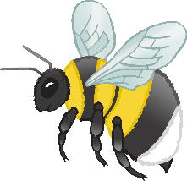
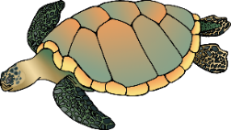




We are closed this week for half term. We return 1st June.
This week is National Gardening week. Please share any planting you do, and what outside adventures you experience. You can also enjoy National Biscuit Day – how about some baking x
- National Walking Month
- Spring

International Nurses Day
National Children’s Day UK
National Numeracy Day
4 2 6
World Bee Day
World Turtle Day
Walk to School Week
Endangered Species Day
International Day of Families
International Tea Day
National Biscuit Day
National Children’s Gardening Week
Eurovision Song Contest

VE DAY Anniversary
What do we aspire to be in the future? Learning about People that help us
Bike / Ride on Day
British Hedgehog Awareness week Learning to protect our decreasing population of Hedgehogs
All have the opportunity to sing
Outdoor learning day
Closed bank holiday

