Jack and Jills Preschool

October 2026

4th

Wednesday
Tuesday
Monday
Friday
Thursday
31st

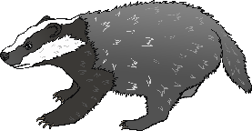
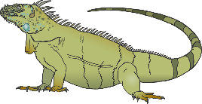

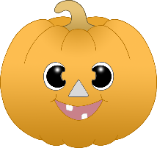


Final week closed for half term
Please share on facebook or tapestry - what you get up to this half term and what you find on your beautiful Autumn walks. PD,PSED,UW

Core Word ‘More’, reading the book ‘monster needs one more’. An Autumn themed - Maths focus this week with lots of numbers and counting CL,L,M

Trip to see the Owls at Hall Place (across 2 Fridays if needed). PSED,UW
Core word ‘Like’ – books ‘Green Eggs and Ham’. Trying different foods – what do you like? PD,PSED,L, CL
Please share your favourite songs from home with us on tapestry or facebook. CL,EAD
Core word this week ‘Finish’, reading book ‘Let me Finish’ CL,L
Celebrating with tea!
And teacher roleplay EAD
Reptile Awareness Day
Learning about different reptiles- life cycle, skin, snakes, lizards and crocs. Reading book ‘the mixed up chameleon’ who would like to be different. UW,EAD
Learning about Earth, Space & Planets. Making aliens & Moving like a space man. UW
9th

Whole Month
Core words – Help, Finish, More, Like (check out British Sign Language for signs. Sounds of the month are T & P. Look for things that begin with those sounds. c&l, L

Celebrating the Harvest Festival and continuing our core word ‘Help’. We will be asking for food donations to offer help to our families. Farm activities and animals. PSED,UW
World Space Week
12th
Please share on tapestry how you celebrate your Grandparents or loved ones this weekend. PSED, UW
Grandparents’ Day
World Teacher’s Day
Clocks go back (UK)
World Singing Day
Halloween
© 2025 Little Owls Resources

Whole Month

1st
2nd
6th

7th

8th

5th

13th

14th

15th

16th

17th

20th
21st

22nd

23rd

25th

19th

