Summer is finally here. This month we will be having a really big push in developing our independence and learning how to keep ourselves safe.
June 2026

Wednesday
Tuesday
Monday
Saturday
Friday
Thursday
Sunday
5th


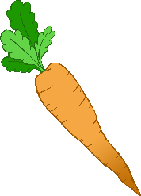









Trip to the farm week- please let us know if you are available to help. We will take groups over a few days.
Preparation for writing week
Exploring growth, change and decay
Learning ball skills
Learning where healthy things come from, tasting and preparing them.
Sorting fruit from vegetables
Looking at habitats & life cycle
Eating outside
Working on developing independence with lots of dress up. Using cutlery to scoop, stab and cut. Cutting with scissors & learning about road safety.
Bike Day
World Bicycle Day
8th

World Oceans Day
International Dinosaur Day
Butterfly Awareness Day
Child Safety Week
Father’s Day (UK)
Stay & play 9.30-10.30
Insect Week
Great Big Green Week
Eat your Veg Day
King Charles III’s official birthday
Int. Picnic Day
© 2025 Little Owls Resources

Ends 12th July

Wimbledon

29th

- Summer
- 30 Days Wild Month
22nd
Summer Solstice (Northern Hemisphere)
21st
^{t}

28th

Whole Month

2nd
3rd
4th
6th

7th

9th

10th

11th

12th

13th

14th

16th

17th

18th

19th

20th

15th

23rd
24th

25th

26th

27th

30th

1st
Whole Month

